You can add Outlook contacts into Lync/Skype so that you can use Lync/Skype to “click to audio call” external contacts. This will only work if the contact has both an email address and a phone number entered into the Outlook Contact.

1. Set-up Lync/Skype to connect with Outlook contacts:
   1. Go to **Tools** > **Options,** and set up the **Personal Information Manager** as: **Microsoft Exchange or Microsoft Outlook.**
   2. Click **OK.**
2. **Wait** for address synchronization to occur (30 to 60 minutes).

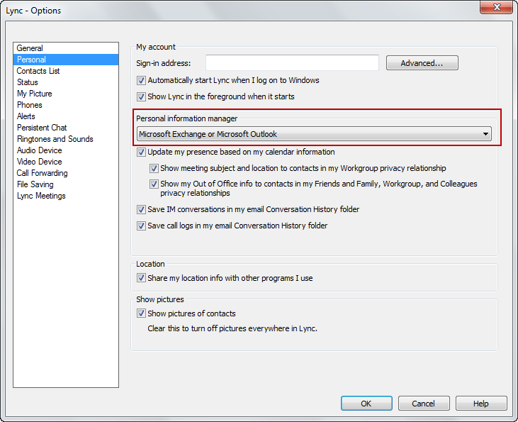

1. In Lync/Skype, search for the contact.

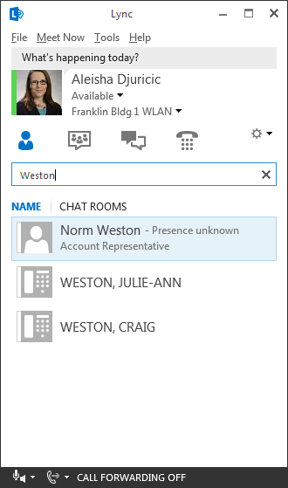

1. Right-click on the contact name and choose **Add to Contacts List.**

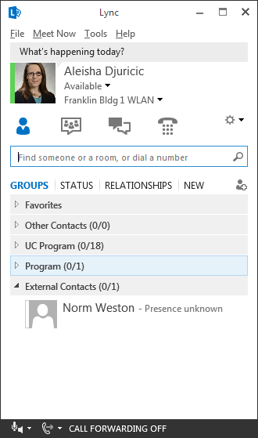

TIP: Place external contacts in a separate group to help you quickly find them.

*Users* ***SHOULD NOT*** *click the Add contact icon in Lync/Skype to add an external contact.*